**Week 2 Submission – Organisational Strategy, Competitive Advantage, and IS**

*32557 – Enabling Enterprise Information Systems*

CB11.B3.101

Team Member:

* Seoyoon Kim (25388442) [Group Leader]
* Jeongjin Lee (25388733)
* Ariel Manueke (25207919)
* Eddie Jeon (25392325)
* Nonthawat Praisompong (25233750)

**Answers:**

1. **Based on the latest information released by UTS (UTS, 2023), we made the diagram below to serve as a flow chart for guiding students through the process of registering for their classes before the commencement of each semester.**

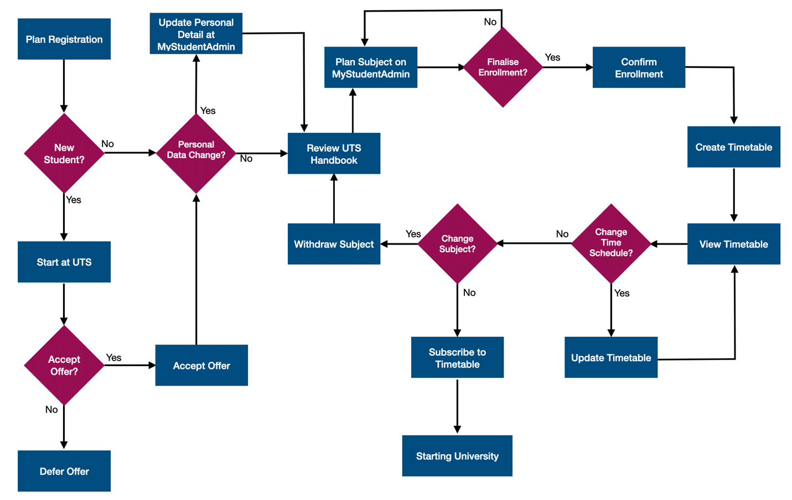

**UTS Registration Flow Diagram**

**Initially, students need to plan their registration for the upcoming semester. For new UTS students, the first step involves accessing the Start at UTS website. From there, they will be directed to a site where they can finalize their offer from UTS. At this stage, students can choose whether to defer or accept the offer. Upon accepting the offer, whether they are new or returning students, it is important to review and update their personal information if there have been any changes or if no data is stored in the UTS database system.**

**Once all the necessary information is updated, students must review the UTS handbook website for relevant courses, assessments, and subject details before proceeding to enrollment. The next step involves planning their subjects using the MyStudentAdmin website. Students can modify their plans as needed before finalizing and confirming their enrollment.**

**After enrolling in all subjects, students may have access to creating their UTS timetable for that specific semester. They have the flexibility to select classes based on their availability or personal preferences, including choosing the class's date and time. Once the timetable is created, students can review their overall schedule and have the option to change any class time, if available on the list.**

**In conclusion, students still can make changes to their subjects by withdrawing from any unwanted courses. This requires repeating the steps, including reviewing the course details through the UTS handbook website. However, if all subjects and timetables are in order, students can opt to subscribe to their timetable schedule using their preferred e-Calendar apps. With the completion of this registration process, students are fully prepared to start their learning journey at UTS.**

1. Information Systems mostly play 2 vital roles in this department, cybersecurity, and Statistics. Australia considers cybersecurity to be the most important which gradually develops into a global need (Australia Government Department of Home Affairs, n.d.).
   1. Cybersecurity

The government recognizes that people are concerned about their privacy and actively trying to protect themselves to maintain digital security (Australia Government Department of Home Affairs, n.d.) and that our lives are surrounded by cyber environment.

Cybersecurity is supported by Home Affairs Department for Australian Government following with implementation of 2023-2030 Australia Cybersecurity Strategy (Australia Government Department of Home Affairs, n.d.) Moreover, working on security-critical and emerging technology including security threats.

The strategy has been pushing the government to become the world leader in cyber security by 2030. The strategy intends to enhance and support cyber security for citizens and businesses by providing six shields against cyber threats Including “strong business and citizenship, Safe Technology, World-class threat sharing and blocking, Protected critical infrastructure, Sovereign capability and Resilient region and global leadership.” (Australia Government Department of Home Affairs, n.d.).

The government also applies information Systems for another purpose on the security of the infrastructure, cooperating with partnerships such as industry and broader community to help operators and infrastructure owners understand the risks which take in the form of “Cybersecurity attack, trusted insiders, malicious disruption to supply chains and attack to physical infrastructure.” (Australia Government Department of Home Affairs, n.d.).

2.2. Statistics

Since 1949, the year that Australian citizenship was introduced. More than 6 million people have become Australian Citizens (Australia Government Department of Home Affairs, n.d.). First, The Department of Home Affairs has been collecting statistics on the former nationality of Australian citizens.

More than 200 nationalities have been converted to Australian and 192,947 people have become Australian citizens in 2022-2023 (Australia Government Department of Home Affairs, n.d.). The top five former nationalities were India (40,361), United Kingdom (17,303), Philippines (12,650), Pakistan (8,513), and Iraq (7,198) (Australia Government Department of Home Affairs, n.d.).

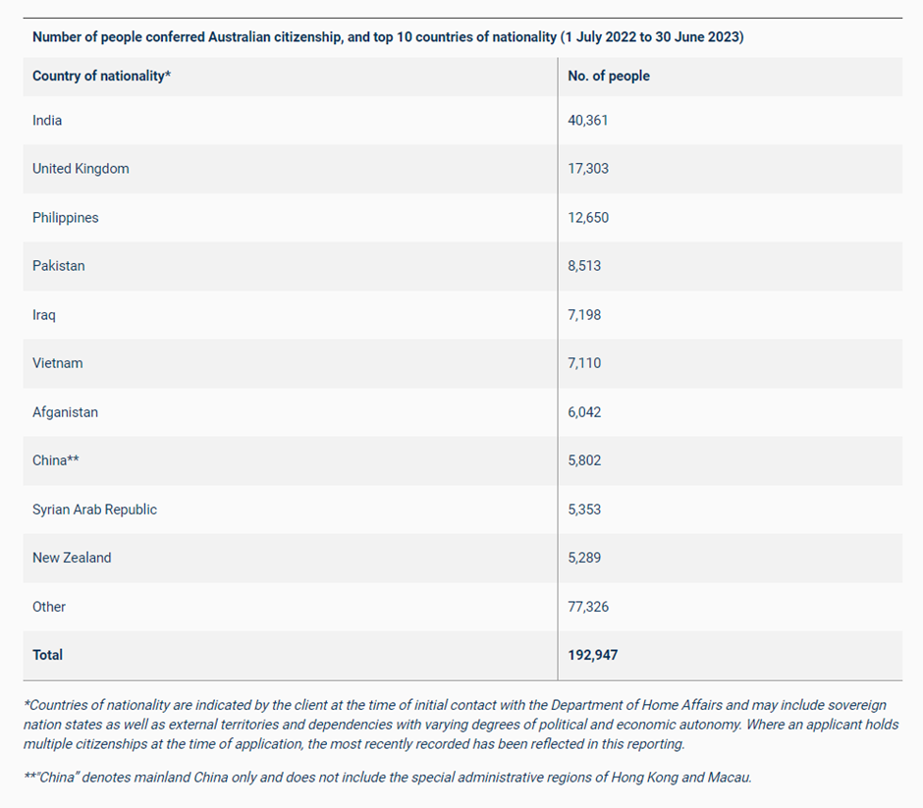

The tables represent former nationalities of Australian citizens from 2022-2023 (Australia Government Department Home Affairs, n.d.).

The government has created the country profile including permanent and temporary migration trends and population migration for Australia’s main migrant sources country which contains statistical data from different types of visas (Australia Government Department of Home Affairs, n.d.).

For people who want to become citizens by permanent migration, the government provides information on Family and child stream visas, especially skill steam visas that require skill sets in the Australian economy consisting of “Business innovation and investment, Distinguished talent, Employer sponsored, Global talent, Regional, skilled independent and state/territory Nominated” (Australia Government Department of Home Affairs, n.d.).

Also collecting the data of people who got temporary visas for a wide range of objectives such as conferences and tourists. Also, specific purposes are medical treatment, study, skilled work, work and holiday visa, and New Zealand citizens, etc. (Australia Government Department of Home Affairs, n.d.).

The government provides operational reports known as time release studies which have been generated by methods from World Customs Organization (WCO) for assessing country’s trade facilitation performance. It has been measured by the average duration of goods arriving at the border until has been transferred into home consumption (Australia Government Department of Home Affairs, n.d.).

Time release studies highlighted success and significant hindrances to import trade which should improve. The details that are provided in the report consist of “a holistic view of the cargo operating environment, enables the measurement of year-on-year improvements on clearance times, enables the identification of other improvement opportunities to further streamline border clearance processes and facilitate trade, provides industry with a measure of border agency performance. (Australia Government Department of Home Affairs, n.d.).

Lastly, the government has been forecasting projections from collected data on migration, work, visits, study, and humanitarian visas (Australia Government Department of Home Affairs, n.d.).

1. **Poter 5 Forces:** strategic management tool that helps determine the competitive landscape of an industry.

3.1. Threat of New Entrants

The introduction of new players into the retailing arena often brings fresh perspectives and innovative approaches, placing pressure on JB Hi-Fi Limited. This pressure may manifest in various forms, including competitive pricing strategies, cost reductions, and the introduction of novel value propositions to attract customers. JB Hi-Fi Limited must adeptly navigate these challenges and devise effective barriers to maintain its competitive advantage.

3.2. Bargaining Power of Suppliers

The majority of companies operating in the Retailing industry procure their raw materials from various suppliers. Suppliers with significant leverage can exert downward pressure on the profit margins attainable by JB Hi-Fi Limited in the market. Prominent suppliers within the Retailing sector leverage their negotiating power to demand higher prices from retail firms. Consequently, heightened supplier bargaining power has the effect of diminishing the overall profitability of the Retailing industry.

3.3. Bargaining Power of Buyers

Buyers within the retailing industry typically have high expectations, seeking top-quality products while aiming to minimize costs. This constant demand places sustained pressure on the profitability of JB Hi-Fi Limited over time. Moreover, the size and influence of JB Hi-Fi Limited's customer base directly correlate with the bargaining power wielded by customers, enabling them to negotiate for greater discounts and incentives.

3.4. Threat of Substitute Products of Services

When a novel product or service addresses comparable customer needs through alternative means, it can detrimentally impact industry profitability. For instance, In the transportation industry, ride sharing services like Uber and DIDI have emerged as substitutes for traditional taxi services. These ride sharing platforms offer customers an alternative way to fulfill their transportation needs, often with added convenience, transparency, and affordability compared to traditional taxis. As a result, the threat of substitute services is high in the transportation industry, particularly when they provide a unique value proposition that sets them apart from existing offerings.

3.5. Rivalry Among Existing Firms

When competition among existing players within an industry is fierce, it tends to drive prices down and diminish the overall profitability of the industry. JB Hi-Fi Limited operates within the highly competitive retailing sector, where intense rivalry among competitors inevitably impacts the organization's long-term profitability. Competitors include Harvey Norman, The Good Guys, Amazon, and eBay.

**Information Systems Contribution to Competitive Strategy:**

JB Hi-Fi's information systems play a critical role in enhancing its competitive strategy by:

* Supporting e-commerce platforms for online sales and customer interactions.
* Leveraging data analytics to understand customer preferences, optimize inventory, and tailor marketing strategies.
* Improving operational efficiency through supply chain management systems, inventory tracking, and order fulfilment processes.
* JB Hi-Fi endeavours to align its pricing competitiveness with other market players through price matching, ensuring parity in the competitive landscape.

1. **(a)** **Competitive advantages of David Jones**

David Jones, Australia's leading premium retailer since 1838, maintains its legacy as the world's oldest continuously operating department store with an unwavering commitment to excellence. With 43 physical stores, an online presence, and international locations, it offers superior products across fashion, beauty, food, and homewares. Acquired by Woolworths Holdings Limited in 2014, David Jones seamlessly blends tradition with contemporary retail, symbolizing sophistication and quality (David Jones, 2024).

* Historical Significance:David Jones' longstanding presence in the Australian retail sector not only demonstrates its resilience but also highlights its historical significance. The fact that it is the oldest departmental store still operating in Australia adds a layer of trust and reliability for customers (Ellem, 2012, p. 456).



David Jones in 1838 (David Jones, n.d.)

* Diverse Product Portfolio:The extensive selection of high-quality international and Australian brands in beauty, fashion, and living categories positions David Jones as a one-stop destination for a wide range of consumer needs. This diverse product portfolio caters to various tastes and preferences, making it appealing to a broad customer base.
* Competitive Pricing Strategy:Offering competitive prices for both international and national brands enhance the store's attractiveness to customers. This pricing strategy not only ensures affordability but also reflects the store's commitment to providing value for money, making it a preferred choice among cost-conscious consumers.
* Strategic Store Locations:The strategic placement of stores in high-value locations minimizes the risk associated with the retail business. High-value locations can attract a steady flow of foot traffic and potential customers, contributing to the store's visibility and accessibility. Additionally, the emphasis on low-risk locations indicates prudent business planning and management (Hansel & Hammond, 2014, pg. 167).
* Customer-Centric Approach: David Jones can further strengthen its position by adopting a customer-centric approach, focusing on enhancing the overall shopping experience. This could involve personalized services, loyalty programs, and digital innovations to engage customers and build long-lasting relationships.
* Sustainable Practices:Emphasizing sustainability initiatives, such as eco-friendly packaging, ethically sourced products, and energy-efficient operations, can align David Jones with the growing consumer demand for environmentally conscious practices. This commitment to sustainability not only appeals to socially responsible consumers but also contributes to the store's positive image.
* Digital Transformation: Investing in e-commerce platforms and digital technologies can help David Jones stay competitive in the evolving retail landscape. This includes an intuitive online shopping experience, virtual try-on options, and leveraging data analytics for personalized recommendations, creating a seamless omnichannel retail experience.

**(b) Competitive advantages of Kmart**

**Based on latest information released by (Kmart. 2022),** Kmart is a leading product development company and a trusted retailer with more than 300 stores throughout Australia and New Zealand and over 37,000 team members. Kmart is recognized as one of the most profitable retailers in Australia offering customers a wide range of everyday products at the lowest prices.

Kmart is commonly subject to comparison with its retail counterpart, Target; nevertheless, its ability to endure within the competitive landscape can be attributed to the following competitive advantages.

* Discount Pricing: Kmart's primary competitive advantage has been its capacity to offer discounted pricing on a wide range of products. By meaning prices lower than many of its competitors as part of an "Everyday Low Prices" (EDLP) strategy, Kmart attracted consumers conscious of budget constraints.

* Wide Product Range: Kmart traditionally offered a broad assortment of merchandise, including clothing, home goods, electronics, toys, and more. This variety allowed Kmart to appeal to a wide customer base and become a one-stop shopping destination for many consumers.

* Store Locations: Kmart strategically positioned its stores in various locations, including suburban areas and shopping malls, making them easily accessible to customers. This widespread presence increased convenience and foot traffic.

* Private Label Brands: Kmart developed private label brands across different product categories. These brands often provided value and quality comparable to national brands at lower prices, enhancing customer loyalty and profit margins.

* Loyalty Programs: Kmart instituted loyalty initiatives such as the Shop Your Way Rewards program, which offered discounts, rewards points, and personalized deals to frequent customers. These programs incentivized repeat purchases and fostered customer allegiance.

* In-Store Experience: Kmart emphasized providing convenient and enjoyable shopping environment for customers. This incorporated elements such as store layout, customer service, and cleanliness, which assisted in distinguishing it from competitors.

* Online Engagement: While Kmart's online presence historically lagged some competitors, it did offer e-commerce options, allowing customers to shop online and have items delivered or pick them up in-store. As seen in the below image (Wesfarmers, 2021, p.18), Kmart’s online engagement and scale increased. This omni-channel approach increased convenience and accessibility for customers.

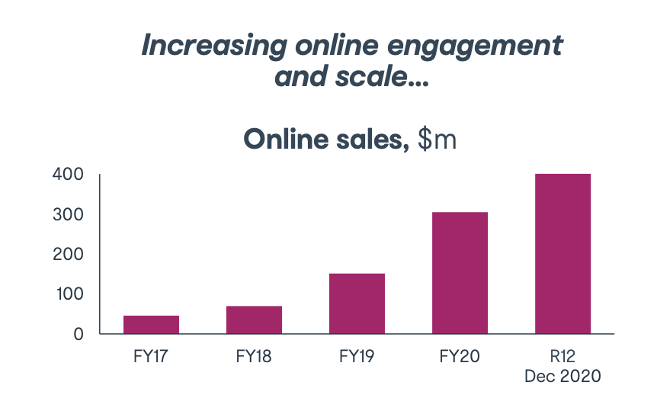

Graph of Kmart’s increasing online presence (Wesfarmers, 2021, p.18)

In conclusion, due to the above competitive advantages, Kmart is still growing its earnings every year and remains a favorite retailer among its customers. According to annual report (Wesfarmers, 2023, p.31)*,* Kmart Group’s sales climbed 16.5% to $10,635 million. Net income of $769 million was up 52.3% year-over-year, representing a record level for the company.

**References:**

Australia Government Department of Home Affairs. (n.d.). 2023-2030 Australian Cyber Security Strategy. <https://www.homeaffairs.gov.au/about-us/our-portfolios/cyber-security/strategy/2023-2030-australian-cyber-security-strategy>

Australia Government Department of Home Affairs. (n.d.). Australian citizenship statistics. <https://www.homeaffairs.gov.au/research-and-statistics/statistics/citizenship-statistics>

Australia Government Department of Home Affairs. (n.d.). Country profiles. <https://www.homeaffairs.gov.au/research-and-statistics/statistics/country-profiles>

Australia Government Department of Home Affairs. (n.d.). Cyber and infrastructure security. <https://www.homeaffairs.gov.au/about-us/our-portfolios/cyber-and-infrastructure-security>

Australia Government Department of Home Affairs. (n.d.). Cyber security. <https://www.homeaffairs.gov.au/about-us/our-portfolios/cyber-security>

Australia Government Department of Home Affairs. (n.d.). Operational reports. <https://www.homeaffairs.gov.au/research-and-statistics/statistics/operational-reports>

Australia Government Department of Home Affairs. (n.d.). Permanent migration. <https://www.homeaffairs.gov.au/research-and-statistics/statistics/country-profiles/permanent-migration>

Australia Government Department of Home Affairs. (n.d.). Temporary migration. <https://www.homeaffairs.gov.au/research-and-statistics/statistics/country-profiles/temporary-migration>

Australia Government Department of Home Affairs. (n.d.). Visa statistics. <https://www.homeaffairs.gov.au/research-and-statistics/statistics/visa-statistics>

David Jones. (n.d.). *About Us*. <https://www.davidjones.com/about-us>

David Jones. (n.d.)*. David Jones Online | Shop Fashion, Beauty, Home & More*. Retrieved from <https://www.davidjones.com/>

Ellem, J. (2012, September).When it's too good to be true, it usually is David Jones. *Keeping Good Companies*. *64*(8), 1444-7614.<https://search.informit.org/doi/10.3316/informit.727625769372059>

Hansel, M., & Hammond, K. (2014, April).Seven corporate governance lessons from David Jones*. Governance Directions. 66(3),* 166-168. <https://search.informit.org/doi/10.3316/informit.256958490256443>

Jb Hi-Fi Limited Porter Five Forces & Industry Analysis. (n.d.). Fern Fort University. <http://fernfortuniversity.com/term-papers/porter5/asx/1907-jb-hi-fi-limited.php>

Kmart. (n.d.). *About Kmart.* <https://www.kmart.com.au/about-kmart/>

SMS USYD (2021, June 29). *A Tale of Two Retail Chains: Target and Kmart. Marketing Under the Microscope #5*. <https://www.smsusyd.com/post/a-tale-of-two-retail-chains-marketing-under-the-microscope-5>

Teneo, N. (2023, March 27). ANCHORAGE CAPITAL PARTNERS COMPLETES ACQUISITION OF DAVID JONES. *Iconic Brand Embarks on New Phase of Growth.* <https://www.davidjones.com/images/assetimages/pdf/information/Anchorage2023.pdf>

UTS (n.d.). *UTS Enrollment Guide*. <https://www.uts.edu.au/sites/default/files/2023-01/UTS_Enrolment_Guide_2022_v1.pdf>

Weber, K. (2023, October 25). David Jones builds new technology team. (n.d.). *David Jones builds new technology team.* <https://www.itnews.com.au/news/david-jones-builds-new-technology-team-601609>

Wesfarmers. (2021, April 20). *Kmart briefing and store tour presentation.* <https://www.wesfarmers.com.au/docs/default-source/asx-announcements/kmart-briefing-presentation-and-store-tour.pdf?sfvrsn=40c50dbb_0>

Wesfarmers. (2023). *2023 Annual Report*. <https://www.wesfarmers.com.au/docs/default-source/reports/2023-annual-report.pdf?sfvrsn=57cde1bb_0>

‌